Date You Filled Out this Report ___________________________________________

Who Helped You Fill out this Report __________________________________________

Your Name _____________________________________________ (you do not have to write this)

Date of Incident ___________________________________________________

Name of Person who was upset or hurt____________________________________

Name of Person being mean___________________________________________

Circle where it happened

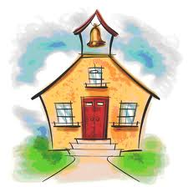School 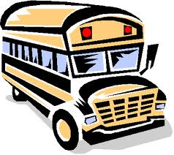 Bus

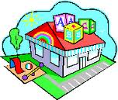 Before/ After School Program 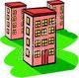 Home

Circle where at school or home or after school it took place

|  |  |  |  |  |
| --- | --- | --- | --- | --- |
| images-7  Bathroom | images-6  Cafeteria | images-3  Recess | images-6  Hallway | images-5  Classroom |
| images-5  Art | gymnasium-flooring  PE | images-4  Library | images-8  Music | Other |

Circle what happened

|  |  |  |  |
| --- | --- | --- | --- |
| images-4  Broke Something | images-2  Kicked | images-1  Punched/Hit | images-7  Wrote on the computer |
| images-3  Told a lie | images  Said Mean Words | Other |  |

Dictation to Teacher/ Adult

What happened?